Our collection comprises of books, digital objects, and other artifacts from the Witcher universe, a fantasy series originally conceived by Andrzej Sapkowski’s in a series of short stories and novels that were eventually adapted into a videogame trilogy. The foundation for Sapkowski’s fantasy world derives from real history with many historical empires, realms, and cultures adapted into a world haunted by monsters and evil spirits from European folklore.

With this historical and cultural basis, we feel there is an opportunity to use metadata that can capture these historical/cultural influences in order to attract historians and admirers of Polish history/culture to this fantasy universe and contribute to their studies. We would also like to use metadata that can direct users/researchers interested in particular aspects of the novels/games whether it be objects/artifacts from particular timelines, events, or characters. This will obviously entail understanding how each element influences the narrative, interacts with characters, and has basis either in real-world folklore/history. Another interesting obstacle will be defining digital objects/entities and what attributes/abilities they convey within the digital landscape of the videogame adaptations. The following 14 items will comprise our collection:

* *Ostatnie życzenie* (Figure 1), or *Last Wish* in English, is the first book of Andrzej Sapkowski’s Witcher series. This book is a collection of short stories and was first published in Polish in 1993, and in English in 2007. [MODS: Jeff]
* The *Blood of Elves* (Figure 2) is the first novel of the Witcher Saga, distinct from the short story compilations published previously; this collection will use the eBook version based on the 2009 original print. [MODS: Dan]
* Topographic map of Ard Skellig (Figure 3) in year 1272 showing the point location of Master-crafted Witcher Armor Set from the School of the Griffin as well as point locations of nearby signposts, traders/towns, and roads as depicted within Witcher 3. {DC: Dan]
* A political map (Figure 4) showing the Northern Realms just prior to the Nilfgardian invasion in 1271, depicted in Witcher 2, and includes some topographical descriptions. [MODS: Dan]
* Mastercrafted Chest Armor (Figure 5) crafted by Yoana of Crow’s Perch using diagram retrieved by Geralt of Rivia while questing in the Skellige Isles; an item within Witcher 3. [VGA: Dan]
* Witcher medallion (Figure 6) worn by Geralt of Rivia bestowed to him by Vesimir upon his completion of the Trial of Grasses. [VGA: Jeff]
* The sword Zireael (Figure 7), given to the main character Geralt’s adopted daughter Ciri in one of the Witcher 3 video game’s potential endings. [VGA: Jeff]
* Dandelion’s lute (Figure 8), gifted to him by elves in Geralt and Dandelion’s first adventure together, *The Edge of the World*. [VGA: Jeff]
* A leshen (Figure 9), one of the monsters Geralt encounters in the books and games of the Witcher series. Leshen, or leshy, are based on the embodiment of the forests themselves in Slavic folklore. [DC: Jeff]
* A bruxa (Figure 10), a name derived from Portuguese folklore, is a type of female vampire Geralt encounters throughout the Witcher game universe. [DC: Dan]
* “The Wolven Storm” - <https://www.youtube.com/watch?v=2bSk-8C76dc> .This song serves as an introduction to the character of Priscilla, a troubadour Geralt encounters in Witcher 3. The song is actually a retelling of the complicated relationship between the witcher, Geralt of Rivia, and the sorceress Yennefer of Vengeburg. [DC: Jeff]
* “No Place Like Home” - <https://www.youtube.com/watch?v=jls8boIDo5I> .This scene depicts Geralt and the “younger” witchers of the school of the Wolf, Lambert and Eskel, being reunited and choosing to spend their evening drinking, telling stories, and getting into trouble. The scene serves as a comedic break in the action near the end of the Witcher 3 game, and explores just how human the mutant witchers can be. [DC: Jeff]
* “A Night to Remember” - <https://www.youtube.com/watch?v=ehjJ614QfeM> . This launch cinematic trailer for the Witcher 3 depicts Geralt’s encounter with a bruxa whom Geralt actually meets during the DLC expansion “Blood & Wine” but does not fight until after the timeline depicted within the Witcher 3. [DC: Dan]
* *Cirilla Fiona Elen Riannon* (Figure 11)is a childhood portrait of the character informally known as Ciri recovered within Avallac’h’s lab in the Skellige Isles. [VGA: Dan]

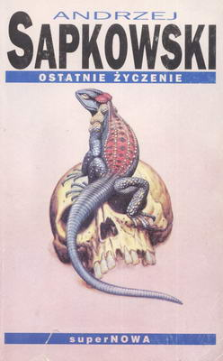

Figure 1

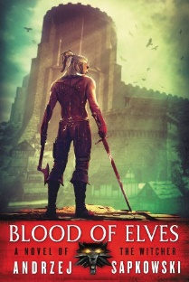

Figure 2

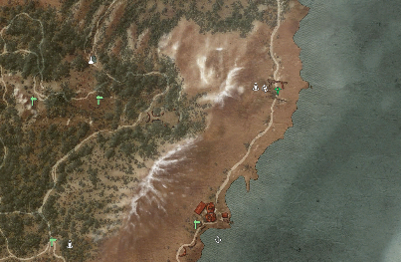

Figure 3

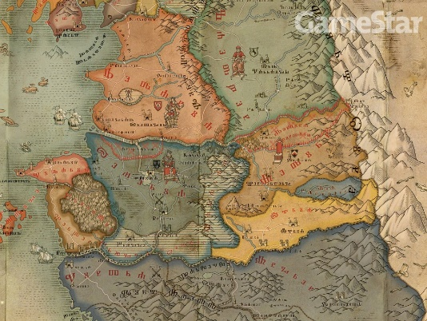

Figure 4

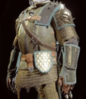

Figure 5



Figure 6

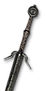

Figure 7

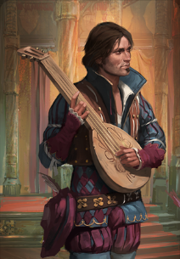

Figure 8

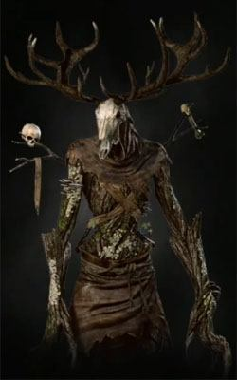

Figure 9

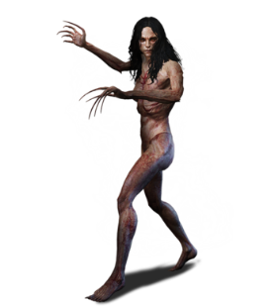

Figure 10

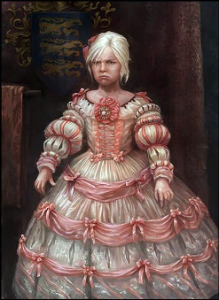

Figure 11